Application for Business Card

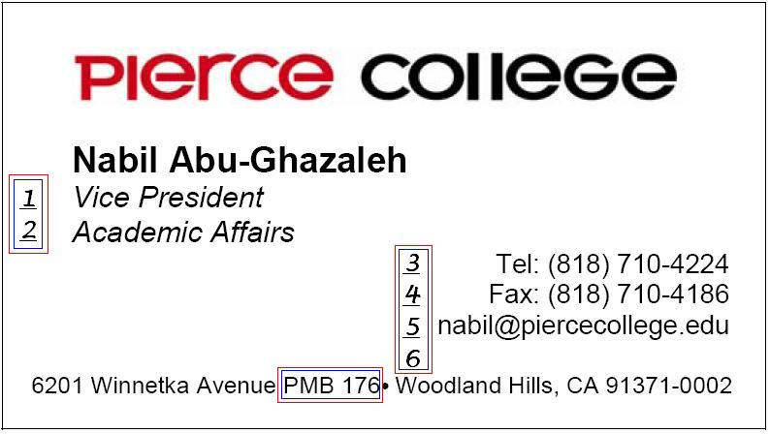

Check one: New Card Revised Card Re-order (No changes)
Name
Line 1
Line 2
Line 3
Line 4
Line 5
Line 6
PMB No:
Return completed form to:
Los Angeles Pierce College CopyTech
6203 Winnetka Ave.
Woodland Hills, California 91371
(818) 710-4422

Signature Date Submitted

